Who Is Krampus?
Explaining the Horrific Christmas Devil
The mythical Krampus is meant to whip children into being nice.
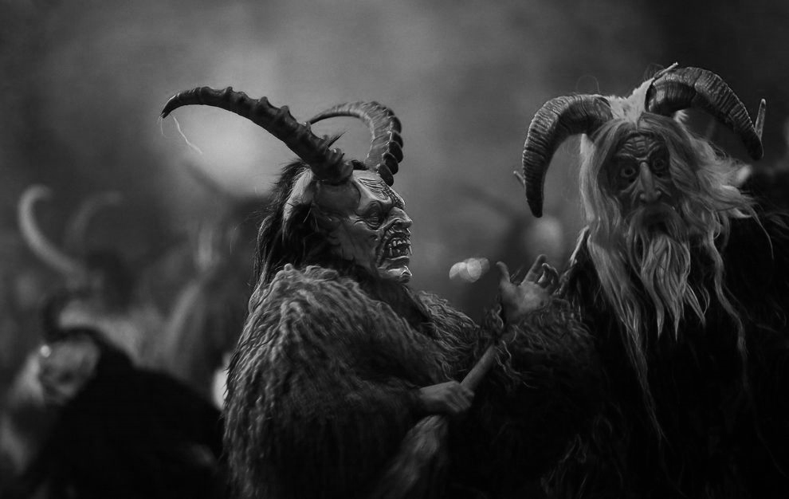
Participants dressed as the Krampus creature walk the streets in search of delinquent children on November 30, 2013 in Austria. Merry—or not-so-merry—Krampus! This beast with Germanic roots is St. Nicholas's other half and scares children into being nice, not naughty. PHOTOGRAPH BY SEAN GALLUP/GETTY IMAGES
By Tanya Basu

National Geographic
Published December 17, 2013

Bad Santa, meet Krampus: a half-goat, half-demon, horrific beast who literally beats people into being nice and not naughty.
Krampus isn't exactly the stuff of dreams: Bearing horns, dark hair, and fangs, the anti-St. Nicholas comes with a chain and bells that he lashes about, along with a bundle of birch sticks meant to swat naughty children. He then hauls the bad kids down to the underworld.
We wondered: What are the origins of this "Christmas Devil"?
Krampus, whose name is derived from the German word krampen, meaning claw, is said to be the son of Hel in Norse mythology. The legendary beast also shares characteristics with other scary, demonic creatures in Greek mythology, including satyrs and fauns.
The legend is part of a centuries-old Christmas tradition in Germany, where Christmas celebrations begin in early December.
Krampus was created as a counterpart to kindly St. Nicholas, who rewarded children with sweets. Krampus, in contrast, would swat "wicked" children and take them away to his lair.
According to folklore, Krampus purportedly shows up in towns the night before December 6, known as Krampusnacht, or Krampus Night. December 6 also happens to be Nikolaustag, or St. Nicholas Day, when German children look outside their door to see if the shoe or boot they'd left out the night before contains either presents (a reward for good behavior) or a rod (bad behavior).
A more modern take on the tradition in Austria, Germany, Hungary, Slovenia, and the Czech Republic involves drunken men dressed as devils, who take over the streets for a Krampuslauf—a Krampus Run of sorts, when people are chased through the streets by the "devils."
Why scare children with a demonic, pagan monster? Maybe it's a way for humans to get in touch with their animalistic side.
Such impulses may be about assuming "a dual personality," according to António Carneiro, who spoke to National Geographic magazine earlier this year about revitalized pagan traditions. The person dressed as the beast "becomes mysterious," he said.
Lump of Coal Preferred?
Krampus's frightening presence was suppressed for many years—the Catholic Church forbade the raucous celebrations, and fascists in World War II Europe found Krampus despicable because it was considered a creation of the Social Democrats.
But Krampus is making a comeback now, thanks partly to a "bah, humbug" attitude in pop culture, with people searching for ways to celebrate the yuletide season in non-traditional ways. National Geographic has even published a book in German about the devilish Christmas beast.
In the U.S., people are buying into the trend with Krampus parties. Monday night's episode of American Dad, called "Minstrel Krampus," highlighted the growing movement of anti-Christmas celebrations.
For its part, Austria is attempting to commercialize the harsh persona of Krampus by selling chocolates, figurines, and collectible horns. So there are already complaints that Krampus is becoming too commercialized.
Looks like Santa might have some competition.

