Switzerland shocked by Muslim teens who refused to shake hands with female tea chers
By Adam Taylor April 6 2016 Washington Post
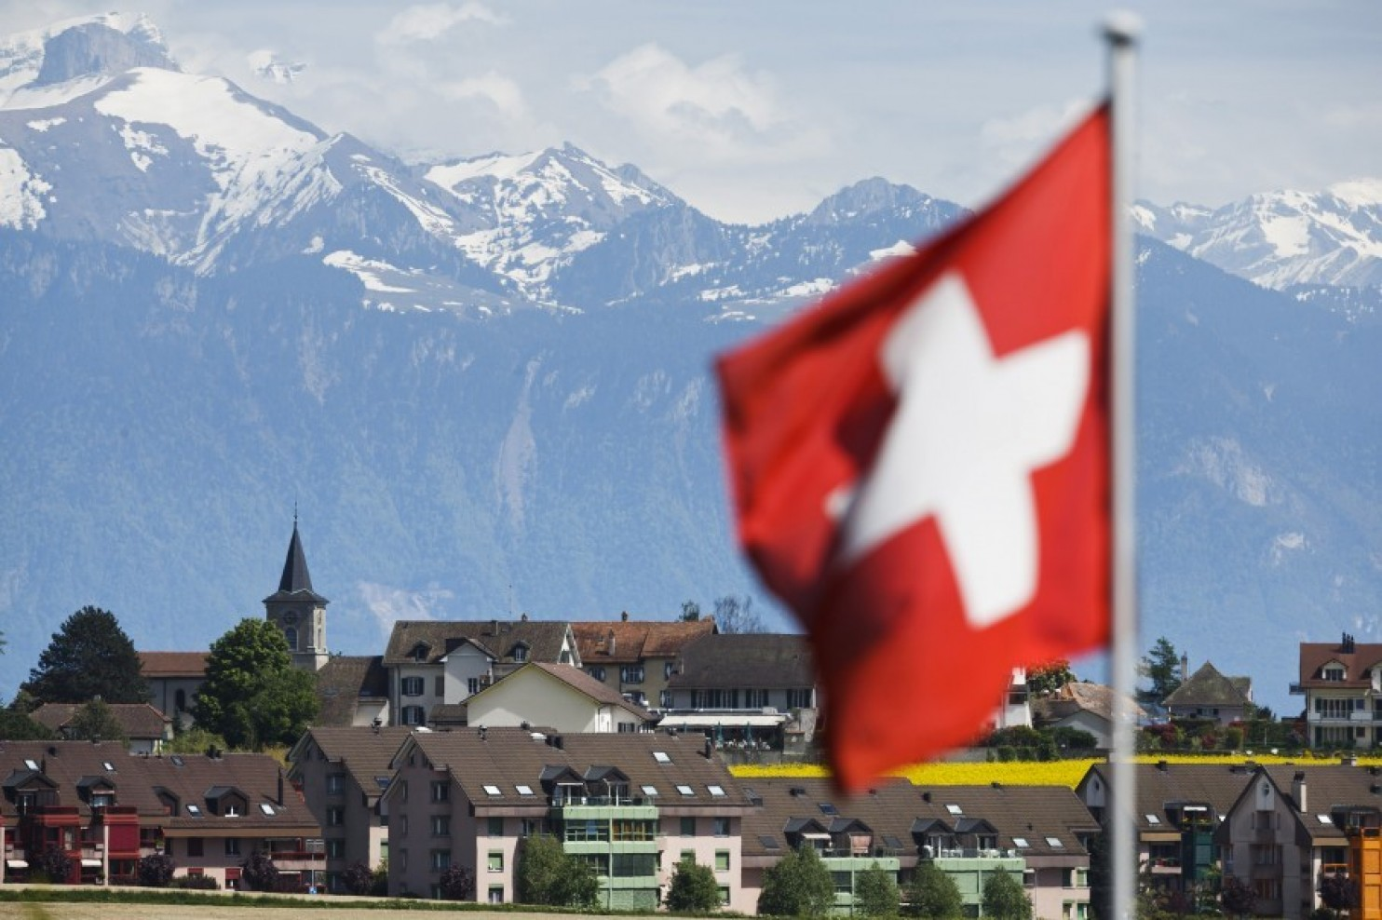

Snow-covered mountains stand beyond residential houses and apartment blocks in Ecublens, Switzerland, on Monday, May 13, 2013. (Valentin Flauraud/Bloomberg)
It's widespread practice for schoolchildren in Switzerland to shake the hands of their teacher at the beginning and end of each day. Now, one school's decision to exempt two children from this tradition – because the children are Muslim and their teacher is a woman – has caused a storm of controversy across the European state.
The two pupils at the school in the town of Therwil, near Basel, had requested an exemption from shaking a female teacher's hand, citing their belief that it would go against Islamic teachings. The local school district later came up with what they felt was an acceptable compromise that could avoid discrimination: The pupils, who are age 14 and 15, would not be required to shake any teachers' hands, whether they were male or female.
However, the plan hit a hitch when the Schweiz am Sonntag newspaper reported on it, sparking a public debate about the compromise. "We cannot accept this in the name of religious freedom," Swiss Justice Minister Simonetta Sommaruga said in an interview with Swiss-German broadcaster SRF. "The handshake is part of our culture.”
Others agreed. "Today's it's the handshake, and what will it be tomorrow?" Felix Mueri, a member of the anti-immigration Swiss People's Party and head of the Swiss parliament's education commission, said in an interview with the 20 Minuten news site.
Both the Swiss Teacher's Union and the local Therwil council have also come out against the plan. However, the school itself has defended the decision, despite the controversy. “They are no longer allowed to shake the hand of any teacher, male or female," headmaster Jurg Lauener told SRF. "For us, that addresses the question of discrimination.”
Authorities in the local Basel-Country canton could overturn the decision, but have not done so. Canton education chief Monica Gschwind suggested to reporters that it was a temporary and "pragmatic" measure.
The situation is the latest controversy over the integration of Islam into Swiss society, where Muslims are thought to make up around 5 percent of the population. In 2009, Swiss voters banned the construction of minarets, and last year the canton of Ticino passed a law that made the wearing of a burqa in public punishable by a $10,000 fine.
The Swiss Muslim community has largely suggested that the boys are misinterpreting Islamic teachings with their refusal to shake their teachers' hands. "[To] the students and parents I would suggest the following reflection: Can the denial of shaking hands be more important than the Islamic commandment of mutual respect?" Montassar Ben Mrad, president of Federation of Islamic Organizations in Switzerland, said in the statement.
However, another group said the backlash against the boys was overblown. "One would think that the continued existence of Switzerland's core values was at stake, when this particular case in fact involves just two high school students who have said they wish to greet their teacher in a different way than with a handshake," a statement from the Islamic Central Council of Switzerland said.

