Dear Parents and /or Guardians, 6 February 2017

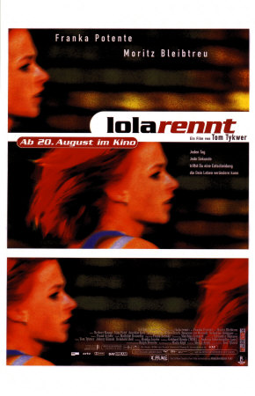
I am going to be gone Thursday and Friday of this week (I am on the committee to write the SAT II German test), and during this time I’d like to show my 2nd year students one of the most famous German films of all time, Run Lola Run (1998).

What is the film about? Lola receives a phone call from her boyfriend Manni. He lost 100,000 DM in a subway train that belongs to a very bad guy. Lola has 20 min to raise this amount and meet Manni. Otherwise, he will rob a store to get the money. Three different alternatives may happen depending on some minor events along Lola's run (summary via IMDB). Here is a link to the trailer: https://www.youtube.com/watch?v=3ea0mG4ahRk as well as the link to the english-language wikipedia page (with a detailed summary): https://en.wikipedia.org/wiki/Run_Lola_Run

Why show this film to the class? Second year students are currently learning about items in the city, as well as two-way prepostions (in front of, behind, above, under, etc.) Besides being one of the most successful foreign films of all time, Run Lola Run also lends itself well to our city theme. Lola runs repeatedly through and past some of the most famous landmarks of Berlin. Is she in front of the bank? Under the bridge? Next to the subway?

Why do we need a permission slip? The film is rated R for violence and language. The violence and language in the film isn’t any worse than you’d see on Law and Order, in my opinion. Feel free to preview the film (available through KCLS and Amazon Video).

This permission slip must be turned in by the beginning of class on Thursday, February 9th, 2017. Please don’t hesitate to contact me with questions. Thank you for your time.

Alysha Holmquist
EHS German Teacher
alysha_holmquist@enumclaw.wednet.edu // 360-802-7826

=========================Return This Portion=========================

Please check one of the following boxes:

Yes, I give permission for my son/daughter to watch all of “Run Lola Run” in German class.

No, I do not give permission for my son/daughter to watch “Run Lola Run.” Please remove them from class and give them another assignment.

Student's Name: Date:
Parent's Signature:

