Name: __________________________________ Datum: _____________________ Stunde: ______

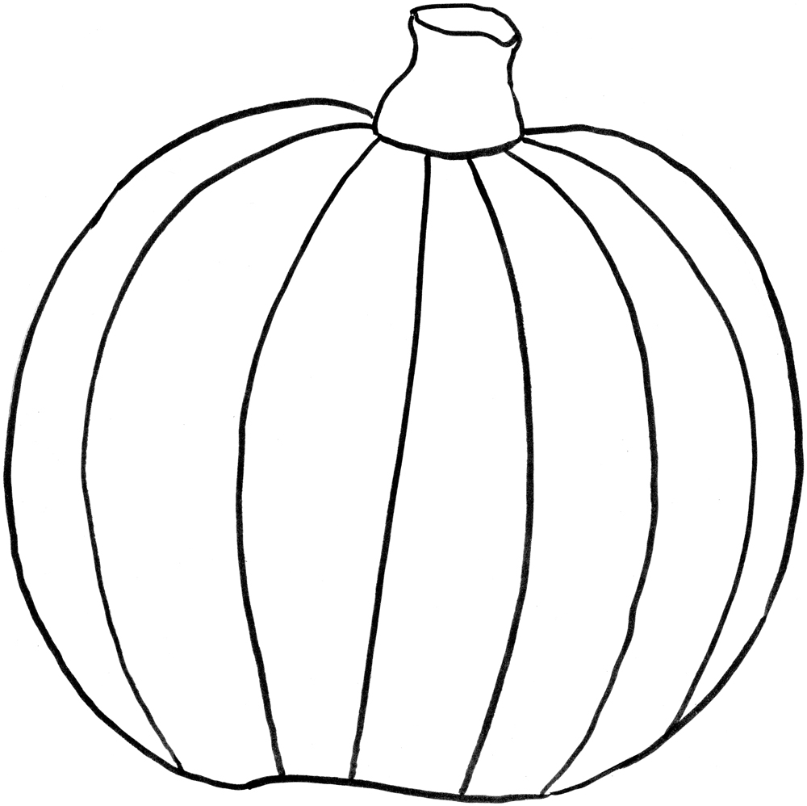
Frohes Halloween!

