How a blunder finished off the Wall
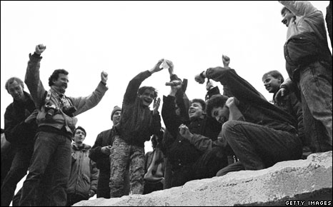

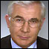
When the Berlin Wall opened on 9 November 1989 Brian Hanrahan was the BBC News reporter on the ground. This year he's been back to talk to some of those whose decisions made this key moment in 20th Century history possible.
From the safe distance of many years later, the opening of the Berlin Wall can be seen as inevitable - the natural consequence of changes that were reshaping Europe. But for most of 1989 it was unthinkable.
And the decision itself was an accident - intended neither to happen the way it did nor to spark off the tumultuous changes that followed.
I heard the inside story of what started this extraordinary rush of events from one of those who made the decision in the East German Politburo - the communist party's ruling body.

Hans Modrow was a communist reformer in the Gorbachev mould. He had only just been given a place on the Politburo as East Germany's leaders tried to head off the demands for change that were sweeping the country. But as a new boy his opinions counted for little.
He remembers an agitated discussion about the travel restrictions - the laws which banned most East Germans from leaving the country and which had sparked off the popular discontent.
At the end of it the party leader, Egon Krenz, suddenly produced a new set of regulations. From now on it would be much easier for East Germans to travel.
What annoyed Mr Modrow was the autocratic way in which the Communist Party still did business. "We couldn't change anything, he says, We sat there like stupid little boys. We just had to do what we were told."
'Blurted out'
Now came a blunder that would bring down the Berlin Wall and the East German state with it. The intention was to announce the changes overnight and phase in the new rules the next morning. Instead one of the Politburo members, Guenter Schabowski, blurted out the plans during a televised press conference - and compounded his error by adding the new rules would come into force "immediately".
Live press conferences were a novelty in communist days, and Mr Schabowski was becoming something of a celebrity through his appearances. Mr Modrow is still scathing about Mr Schabowski's preening in front of the media.
“The Politburo had announced the decision to allow people to cross the border, but the order wasn't to be published until 0400 in the morning,” said Mr. Modrow. “But Mr Schabowski didn't notice. He went into an international press conference. And he was so arrogant and full of himself. We had no idea this was happening."
Mr Schabowski's announcement was complicated and bureaucratic, and like many others that evening I puzzled over it before concluding that it signaled free travel. If this was true it would mean the end of the Berlin Wall because the whole fearsome structure with its watchtowers, barbed wire and guard dogs had become redundant.
East Berliners were rather quick off the mark. Tens of thousands of them started turning up at the border demanding to be let across. But the guards hadn't been told anything - their standing orders were to stop anyone crossing. Until recently they'd been instructed to shoot to kill anyone who tried. This night they tried to turn people back - but after a generation being pushed about, Berliners turned belligerent and refused to go.
Stunned guards
The standoff between the armed guards and the angry crowds soon grew tense and dangerous. The guards asked their headquarters for orders but the government ministries in charge of security told them nothing. Mr Modrow and the other Politburo members had gone home unaware of what was going on.
With radio and TV reports bringing more people on to the streets, Mr Modrow says it was the border guards themselves who decided what to do.
"With hindsight it's the border guards we must thank, not any of us in the Politburo. The guards on the ground - at the time - made the critical decision. They ignored their standing orders. They said, 'Open the border.'"
I arrived at the main border post just in time to see the barriers swing open as the guards gave up any attempt to regulate the crossing. They looked stunned at the mass of people streaming past them. Their whole world was collapsing about them.
As East Germany's leaders were ignorant of what was happening, the rest of the world was already watching on television. In Washington, James Baker was at lunch with the President of the Philippines, Cory Aquino, when he was told the news. A short while later, hearing that people were taking sledgehammers to the wall, he abandoned the table and hastened over to the White House.

Changed world
There he and President Bush were taken aback at what they saw. They'd had no warning. "It was happening before our eyes. Maybe the Soviet leadership saw it coming but I don't think anyone in allied capitals anticipated it happening with that speed."
Mr Baker admitted candidly that he was daunted by the scale of the task ahead in reshaping world alliances. As the West's chief diplomat he would have to do most of it. "The world as I had known it all my adult life changed that day, and it changed fundamentally. I had grown up with the Cold War. Everyone in my generation had."
In the Kremlin the man most responsible for the change slept through it. The Soviet leader had been tipped off a few days earlier about the way the East Germans were thinking.
Mr Gorbachev chuckled as he remembered the rush to tell him what had happened. "They reported to me quite early in the morning. They were in a hurry to let me know. We had been expecting it to happen. It could have happened at any time."
And he was matter-of-fact about the consequences. "I took note of the report. It moved us on to a new phase. Not that I was enthusiastic about it, but I accepted it as something that had to happen. We understood that the time was coming for the German problem to be addressed."
In London Douglas Hurd had been foreign secretary for just 15 days. He noted the news from Berlin in his diary. "The regime and now the wall are crumbling fast," he wrote. But he was already wondering how he could persuade the Prime Minister, Margaret Thatcher, to consider the idea of a united Germany.
Berliners were only just opening the bottles of sparkling Sekt at the beginning of a street party that would last for days. Many were still uncertain what exactly was happening. In a few short hours they had changed the contours of world politics and there could be no going back. The inevitable, unthinkable accident had happened.

Celebrations begin as the German capital marks the fall of the Berlin Wall

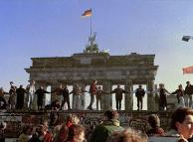
Thousands of curious Berliners in the center of the German capital have been sizing up over 1,000 giant dominos set to topple to mark the 20th anniversary of the fall of the Berlin Wall.

The 2.5-meter high (8 ft. 2 in.) colorful plastic foam dominos have been lined up along a 1.5 kilometer (one mile) stretch of terrain once occupied by the Berlin Wall in the area around the Brandenburg Gate and the Reichstag parliament building.
The dominos were tipped over in a ceremony to symbolically mark the toppling of the wall and the beginning of the end of communist East Germany on November 9, 1989.
The dominos had been decorated by various artists as well as Berlin school children to reflect upon what reunification represents to the people of East and West Germany.

The dominos are a powerful, symbolic message
Many of the dominos carry messages, like "We are one people". One labeled "bleeding heart" shows a sword cutting through the city of Berlin, starting a crimson flow of blood speckled with crosses.
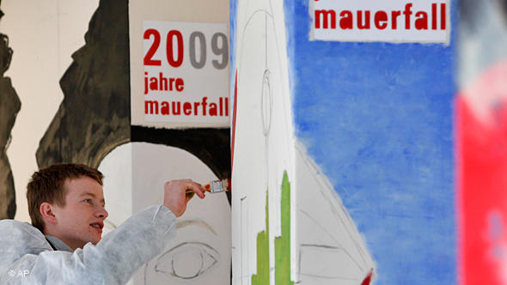
"It's really very beautiful, it's a terrific idea," said Barbara Graff, a 74-year-old city resident. Recalling November 9th, she said that she went to West Berlin's main shopping street, Kurfuerstendamm, and "distributed money to the people arriving en masse from the East."
Bildunterschrift: Artists, students and school children decorated the dominos symbolizing the fall of the Wall

