Name: ___________________________________ Datum: _____________________ Stunde: _____
GOODBYE LENIN

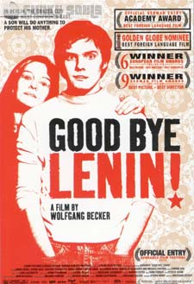
- Anleitung zur Goodbye Lenin: Read the introduction to Goodbye Lenin below. Write down at least 4 facts from the article before watching the movie.

Berlin is the capital city of Germany. It had a turbulent history and became the focus of divisions within Germany itself after the Second World War.

In 1961, the city was divided into two parts by a wall that became known as the Berlin Wall. This wall was seen to separate communist East Germany (the German Democratic Republic (GDR)) from capitalist West Germany (the Federal Republic of Germany (FRG)).

Life for the Germans who lived in East Germany was very diff erent from those who lived in the West. There were none of the ‘trappings’ of western culture, for example, fast food chains like Burger King, furniture chains such as IKEA, or clothes stores like Marks and Spencer. Some families living in East Berlin became separated from close relatives, or friends, living only a short distance away in West Berlin, on the other side of the wall. The East German government (GDR) controlled people’s lives much more rigidly than in the West and although many East Germans preferred the communist system, lots of others on both sides of the wall longed for a united Germany.

Wolfgang Becker, the director of Goodbye Lenin, had close links with East Berlin. He was anxious to give audiences, who perhaps knew very little about Berlin’s history, an insight into the differences between the two halves of this great city in the late 1980s. He decided to do this by focusing on one family, the Kerners, in his film. He does not give the audience an entirely positive representation of the West or an entirely negative view of the East. Instead he uses humour, mixed with some sadness, in order to explore what was lost and what was gained during the turbulent eight months when Christiane slept and the Berlin Wall was finally pulled down.

__________________________________________________________________________________________________

__________________________________________________________________________________________________

__________________________________________________________________________________________________

__________________________________________________________________________________________________

- Kurze Zusammenfassung: Use a dictionary (the book version – not online!) and look up the words below. Write the correct English word – also write the correct article on the line when needed. You may need to look for the letters m, f, or n. (m = der, f = die, n = das). For verbs, the infinitive is in parentheses. You may work with your partner.

- ______ Atem: 6. retten:
- ______ Aufregung: 7. schaffen:
- ______ Herzinfarkt: 8. erfahren:
- ______ Wunder: 9. erkennt (erkennen):
- ______ Sieg: 11. erlebt (erleben):
- ______ Bürger(in): 12. erwacht (erwachen):
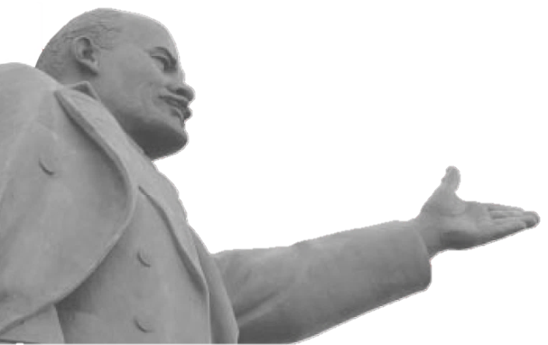
Kurz vor dem Fall der Mauer fällt Alexs Mutter nach einem _____________________ins Koma. Sie ist eine selbstbewusste _________________der DDR, - und schläft durch den _______________ des Kapitalismus. Als sie wie durch ein ____________________nach acht Monaten die Augen wieder öffnet, __________________ sie in einem neuen Land. Sie hat nicht ________________, wie West-Autos, Coca Cola, und Fast-Food-Ketten in den Osten kommen. Sie darf von alles nicht ________________: ihr Herz ist zu schwach – vielleicht kann sie die _________________ nicht überstehen. Alex bekommt keine ________________-pause. Um seine Mutter zu _______________, muss Alex jetzt auf 79 Quadratmetern Plattenbau die DDR neu
_________________. Schnell __________________ er, dass
dieser Plan nicht so einfach wird...
Lenin, 1870-1924. Soviet revolutionary, supporter
of Marxist theory, creater of the Soviet Union.
- Wer ist das? Below are pictures from the film Goodbye Lenin. Using the Wortschatz below to describe the Aussehen (appearance) and Persönlichkeit (personality) with 2-3 words, and fill in the information about the four characters. Feel free to look up other adjectives in the dictionary.
Wortschatz: Leute beschreiben (describing people)
Aussehen: schön, (un)attraktiv, hübsch / niedlich (cute), blass (pale), dünn (thin), kräftig (powerful), erschöpft (exhausted, gute Haare, gute Kleidung
Persönlichkeit: sympathtisch / nett (nice), traurig, malancholisch, launisch (moody), lustig (funny), fleißig (hard-working), freundlich, ehrgeizig (ambitious), kreativ, einsam (lonely), rebellisch, realistisch, idealistisch, modern

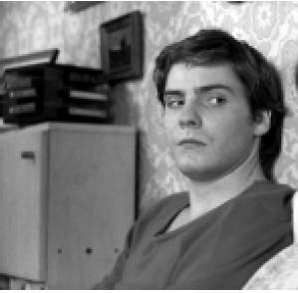
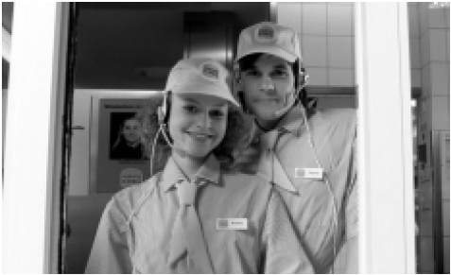
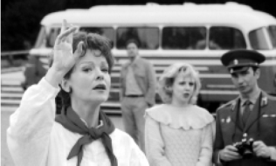

Name:
Alter:
Kommt aus:
Aussehen:

Persönlichkeit:

Name:
Alter:
Kommt aus:
Aussehen:

Persönlichkeit:

Name:
Alter:
Kommt aus:
Aussehen:

Persönlichkeit:

Name:
Alter:
Kommt aus:
Aussehen:

Persönlichkeit:

Alex Kerner

- Ostprodukte! These “east products” act as representations of life in the German Democratic Republic, highlighting a shared feeling of ‘ostalgie’ or ‘east nostalgia,’ and even sometimes symbolizing the “ideal East German world.” Match the GDR product to its English translation by drawing a line between the two items.

- Mocha Fix Gold a) These peas come in a jar.
- Spreewald Gurken b) Dried beans… ready in only 10 minutes!
- Trabant c) This coffee comes in special gold packages.
- Globus Erbsen d) Speciality pickles from Brandenburg.
- Tempo Bohnen e) This car could take up to 3 years to get.

5. Fragen zur Film. Answer the questions below in English after viewing the film.
- What is your impression of life in the DDR after watching this film?

- What were some of the main differences you observed between East Germany and West Germany in the film?

- How did the West influence Ariane and her boyfriend after the wall fell?

- What obvious signs of capitalism did the film show?

- Why do you think that some of the characters found the unification process challenging?

- Name at least 3 products that Alex searches for to convince his mother she is still in the DDR.

- How does Christiane react to her children’s deception?

- How would you have felt growing up as an East Berliner, how would you have felt when the wall fell, and also after the Reunification?

- Why, in your opinion, would anyone want to return to the time before the wall fell?

- Why do you think this film’s original title is in English? How does this relate to the film?

- Goodbye Lenin! is the most successful German film of all time. Why do you think that is?

Auf Deutsch: Deutsche Demokratische Republik (DDR)
Auf Deutsch: Bundesrepublik Deutschland (BRD)
Plattenbau: It is DDR building constructed of large prefabricated concrete slabs.

