Meine Deutschlandreise
My trip to Germany

Adresse meiner Gastfamilie in Deutschland:
My host family’s address:

______________________________________________________________________
______________________________________________________________________
______________________________________________________________________
Telefon #: ________________________________________________

Handy #: _________________________________________________

Adressen und Telefon # von meinen Freunden:
My friends’ addresses/numbers:

_____________________________________________________________________________________________
_____________________________________________________________________________________________
_____________________________________________________________________________________________
_____________________________________________________________________________________________
Handy # von meinen Lehrern:
My teacher’s cell phone numbers:

_____________________________________________________________________________________________
_____________________________________________________________________________________________

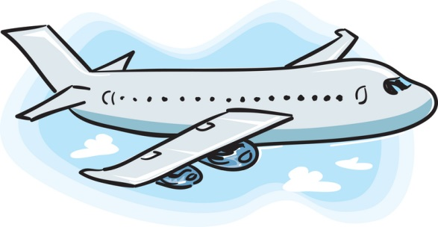
Meine Ankunft My arrival

Meine Gedanken vor der Reise nach Deutschland:
My thoughts before coming to Germany:

_____________________________________________________________________________________________
_____________________________________________________________________________________________
_____________________________________________________________________________________________
_____________________________________________________________________________________________
Unsere Fluggesselschaft war: ______________________________
Our airline was:

Wir flogen um ________ ab. Der Flug dauerte ______ Stunden.
We flew out at ... The flight lasted … hours.

Unsere Flugroute war: our flight route was:

_____________________________________________________________________________________________
_____________________________________________________________________________________________
Während des Fluges habe ich… during the flight I …

_____________________________________________________________________________________________
_____________________________________________________________________________________________
Wir kamen um ____ Uhr in Deutschland an. We arrived in Germany at…

In den USA war es dann ____ Uhr. It was … o’clock in America.

Erste Eindrücke: First Impressions:

_____________________________________________________________________________________________
_____________________________________________________________________________________________
_____________________________________________________________________________________________
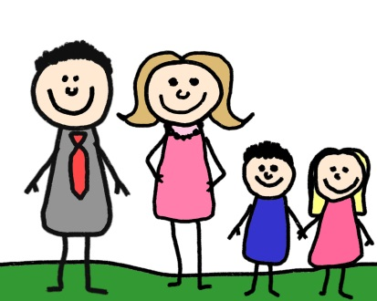
Meine Gastfamilie My host family
Meine Gasteltern heisst: My host parents are named:
_____________________________________________________________________________________________
Wann haben sie Geburtstag? When are their birthdays?
_____________________________________________________________________________________________
Was machen sie beruflich? What are their jobs?

Meine Gastgeschwister:  My host siblings: | Geburtstage:  Birthdays: | Hobbies:

Erzähle etwas über deine Gastfamilie und das Leben zu Hause: Write something about your host family and life at home:

_____________________________________________________________________________________________
_____________________________________________________________________________________________
_____________________________________________________________________________________________
Wie sind die Häuser in Deutschland gebaut und was ist anders an einem deutschen Haus? How are German houses different from American ones?

_____________________________________________________________________________________________
_____________________________________________________________________________________________
_____________________________________________________________________________________________
Wie verbringt deine Gastfamilie ihre Abende? How does your host family spend their evenings?

_____________________________________________________________________________________________
_____________________________________________________________________________________________
_____________________________________________________________________________________________
Wie geht deine Gastfamilie mit der Energie um? Sind dir bestimmte Energiespar-maßnahmen oder Recycling-Methoden aufgefallen? How does your host family consume or save energy? Did you notice any energy conserving or recycling practices?

_____________________________________________________________________________________________
_____________________________________________________________________________________________
_____________________________________________________________________________________________
_____________________________________________________________________________________________
_____________________________________________________________________________________________
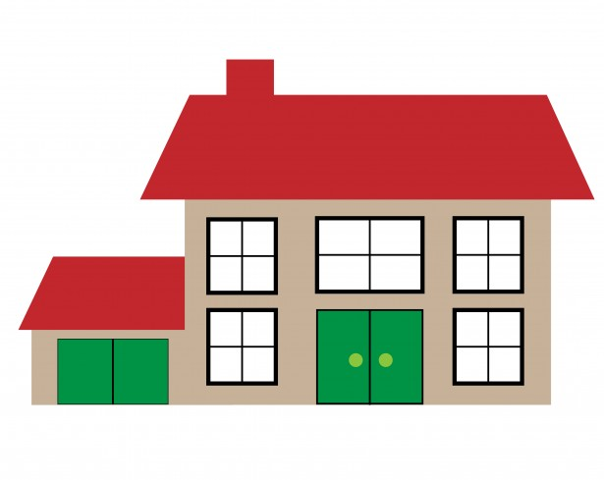
_____________________________________________________________________________________________
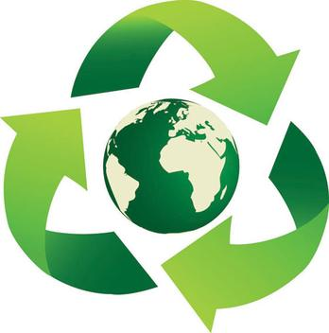

In der Schule at school

Meine Partnerschule heisst: my partner school is called:

_____________________________________________________________________________________________
Wann beginnt und endet der Unterricht? When do classes begin and when do they end?

_____________________________________________________________________________________________
Wie viele Pausen gibt es und wie lange sind sie? How many breaks are there and how long are they?

_____________________________________________________________________________________________
Wie sind du und dein Partner in die Schule gekommen? How do you and your partner get to school?

_____________________________________________________________________________________________

Welche Unterschiede gibt es zwischen der deutschen Schule und deiner amerikanischen Schule? Which differences do you notice between the German school and your American school?

_____________________________________________________________________________________________
_____________________________________________________________________________________________
_____________________________________________________________________________________________
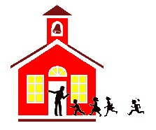
_____________________________________________________________________________________________

Im Unterricht in class

Schau dir das Klassenzimmer an. Was hängt an den Wänden? Look at the classroom. What kinds of things are on the walls?
_____________________________________________________________________________________________
_____________________________________________________________________________________________
_____________________________________________________________________________________________

Wie sieht das Klassenzimmer aus? Zeichne unten, ein typisches deutsches Klassenzimmer. How does the classroom look? Draw a typical German classroom below.

Was gefällt dir (nicht) an deutschen Klassenzimmern? What do you like/not like about German classrooms?

_____________________________________________________________________________________________
_____________________________________________________________________________________________
_____________________________________________________________________________________________
Was kann ich verstehen? Hör gut zu und mach eine Liste von 20 deutsche Wörter, die du verstehen kannst. Schreib auch die englische Bedeutung. What can I understand? Listen carefully to the teacher and write down 20 words you hear and know. Include the English meaning.
- ________________________
- ________________________
- ________________________
- ________________________
- ________________________
- ________________________
- ________________________
- ________________________
- ________________________
- ________________________

- ________________________
- ________________________
- ________________________
- ________________________
- ________________________
- ________________________
- ________________________
- ________________________
- ________________________
- ________________________

Nenne die englische Übersetzung für die folgende Begriffe: Translate the following words into English:

Abifeier: Leistungskurs:
Abistreich: Schultüte:
Hitzefrei: Sitzenbleiben:
Klassenlehrer: Zeugnis:
Klassensprecher: Klassenfahrt:
Klassenbester: Vertrauenslehrer:
Ein Vergleich A comparison

Americans have states. Germans have…
Americans spend dollars. Germans spend…
Americans spend Jackson & Franklin. Germans spend…
Americans correct with White Out. Germans correct with…
Americans use Scotch Tape. Germans use…
Americans glue with Elmer’s. Germans glue with…
Americans trade via NYCSE (stock ex.) Germans trade via…
Americans trade stock in NYC. Germans trade in…
Americans drink Rootbeer. Germans drink…
Americans use Kleenex. Germans use…
Americans watch ABC, NBC & MTV. Germans watch…
Americans read the National Inquirer. Germans read…
Americans go to Hawaii. Germans go to…
Americans have 2 weeks paid vacation. Germans have…
Americans listen to Beyonce. Germans listen to…
Americans get electricity at 110 volts. Germans have…
Americans drive on freeways. Germans drink on the…
Americans buy clothes. Germans shop at…
Americans get A, B, C, D & F. Germans get…
In der Freizeit und beim Einkaufen
Free time and shopping

Was hast du in deiner Freizeit unternommen? What did you do in your free time?

_____________________________________________________________________________________________
_____________________________________________________________________________________________
_____________________________________________________________________________________________
Was hast du am Abend unternomen? What did you do in the evenings?

_____________________________________________________________________________________________
_____________________________________________________________________________________________
_____________________________________________________________________________________________

Meine Lieblingsgeschäfte in Deutschland sind: My favorite shops/stores in Germany are:

___________________________ ____________________________
___________________________ ____________________________
___________________________ ____________________________

Ich habe mir die folgende Sachen gekauft. I bought the following items:

___________________________ ____________________________
___________________________ ____________________________
___________________________ ____________________________
Entertainment

Welche Fernsehprogramme hast du in Deutschland kennengelernt? Which TV shows did you watch?

_____________________________________________________________________________________________
_____________________________________________________________________________________________
Welche amerikanischen Fernsehsendungen sind in Deutschland sehr beliebt? Are there any American TV shows/series that are very popular in Germany?

_____________________________________________________________________________________________
_____________________________________________________________________________________________
Welcher Film hat dir besonders gut gefallen? What is your favorite German movie?

_____________________________________________________________________________________________
_____________________________________________________________________________________________
Welche Filme sind zur Zeit in Deutschland angesagt? What are the most popular movies in Germany right now?

_____________________________________________________________________________________________
_____________________________________________________________________________________________
Wie heissen 3 berühmte deutsche Schauspieler? What are the names of three famous German actors?

_________________________________________________________

_________________________________________________________

_________________________________________________________

Warst du im Kino? Welche Filme hast du gesehen? Did you go to the movies? Which films did you see?

_____________________________________________________________________________________________
_____________________________________________________________________________________________
Welche deutschsprachigen Lieder hast du kennengelernt? What German-speaking songs did you get to know?

Titel title Gruppe group

___________________________ ____________________________
___________________________ ____________________________
___________________________ ____________________________
___________________________ ____________________________

Welchen deutschen Radiosender und Musikshows kennst du? Which German radio stations and music shows do you know?

_____________________________________________________________________________________________
_____________________________________________________________________________________________
Kennst du fünf wichtige deutsche Zeitungen / Zeitschriften? Do you know five important German newspapers/magazines?
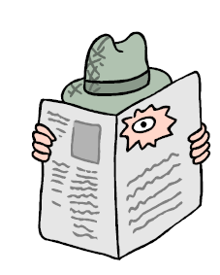
- ______________________________________________________
- ______________________________________________________
- ______________________________________________________
- ______________________________________________________
- ______________________________________________________
Essen und Trinken Food and Drink

Wo kauft deine Gastfamilie ein? Where does your host family shop for groceries?

_____________________________________________________________________________________________
_____________________________________________________________________________________________
Wann machen die Geschäfte auf und wann schliessen sie wieder? At what time to the shops open and at what time do they close?

_____________________________________________________________________________________________
_____________________________________________________________________________________________
Welche deutschen Lebensmittel und Gerichte isst du am liebsten? What are you favorite German groceries and what are your favorite German foods?

_____________________________________________________________________________________________
_____________________________________________________________________________________________
Welche Spezialitäten sind typisch für deine Stadt? Are there any typical food specialties in your city?

_____________________________________________________________________________________________
_____________________________________________________________________________________________

Wie ist das Essen in deiner Gastfamilie organisiert? Isst deine Gastfamilie oft zusammen? Gibt es eine besondere Tischordnung oder bestimmte Gewohnheiten? How are the meals in your host family organized? Do you all eat together? Are there any special habits or customs at the table?

_____________________________________________________________________________________________
_____________________________________________________________________________________________
_____________________________________________________________________________________________
Verkehr transportation

Welche öffentlichen Verkehrsmittel hast du in Deutschland benutzt? Which means of public transportation did you use in Germany?

_____________________________________________________________________________________________
_____________________________________________________________________________________________
_____________________________________________________________________________________________
Wie viel kostet ein Bahn-/Bus-ticket? How much is a train/bus ticket?
Bahn: _____________________ Bus: ______________________
Sind die öffentlichen Verkehrsmittel in Deutschland anders als in den USA? Wie? Is public transportation different in Germany? How?

_____________________________________________________________________________________________
_____________________________________________________________________________________________
_____________________________________________________________________________________________
Nenne drei Automarken, die du in Deutschland gesehen hast: Name three car brands you have seen in Germany:
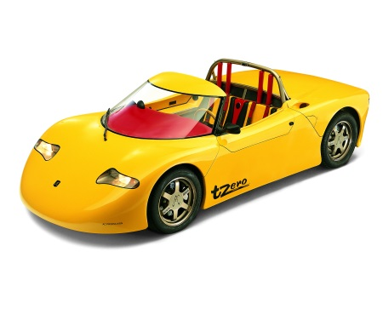
- _________________________________
- _________________________________
- _________________________________
Gibt es Unterschiede zwischen deutschen und amerikanischen Autos? Welche? Are there differences between German and American cars? Which?

_____________________________________________________________________________________________
_____________________________________________________________________________________________
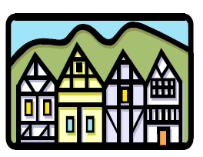
Meine Partnerstadt My host town

Meine Partnerstadt heisst: My host town is called:

_____________________________________________________________________________________________
Welche Sehenswürdigkeiten gibt es in deiner Partnerstadt? What sights can you admire in your partner town?

_____________________________________________________________________________________________
_____________________________________________________________________________________________
Gibt es eine Altstadt? Wie sieht sie aus? Is there an old town center? How does it look?

_____________________________________________________________________________________________
_____________________________________________________________________________________________
Wie viele Einwohner hat deine Partnerstadt? How many people live in your partner town?

_____________________________________________________________________________________________
Welchen Eindruck hast du von deiner Partnerstadt? Gefällt dir die Stadt? What is your impression of the town? Do you like it?

_____________________________________________________________________________________________
_____________________________________________________________________________________________
In welchem Bundesland liegt deine Partnerstadt? What federal state is the town in?

_____________________________________________________________________________________________
Gibt es einen besonderen Treffpunkt für junge Leute? Is there any specifc place for young people to hang out?

_____________________________________________________________________________________________
Beschreibe die Unterschiede, die du im Vergleich zu deiner Heimatstadt siehst: Describe the differences between your partner town and your home town:

_____________________________________________________________________________________________
_____________________________________________________________________________________________
_____________________________________________________________________________________________
Wie sieht deine Umgebung aus? How does your neighborhood look?

_____________________________________________________________________________________________
_____________________________________________________________________________________________
Nenne einen Fluss oder einen See in deiner Partnerstadt: Name a river or lake in your partner city:

_____________________________________________________________________________________________
Mit meiner Gastfamilie war ich in: My host family took me to:
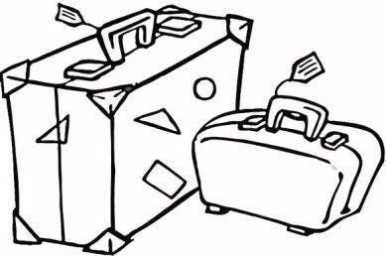
_____________________________________________________________
Datum: _________________________________________________

Wir waren ______ Stunden unterwegs. The trip took … hours.

Folgendes habe ich auf dem Ausflug erlebt: I saw the following…

_____________________________________________________________________________________________
_____________________________________________________________________________________________
Mir hat besonders gut gefallen / Mir hat nicht gefallen: I liked… I didn’t like…

_____________________________________________________________________________________________
_____________________________________________________________________________________________
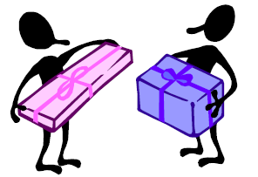
Abreise departure

Gab es eine Abschiedsfeier? Wie und wo hast du mit deiner Gruppe/Familie Abschied gefeiert? Was there a goodbye party? Where and how did you say goodbye to your host family?

_____________________________________________________________________________________________
_____________________________________________________________________________________________
Welches sind deine stärksten Eindrücke von der Deutschlandreise? What are your strongest impressions of your trip to Germany?

_____________________________________________________________________________________________
_____________________________________________________________________________________________
Gibt es etwas was du besonders vermissen wirst? Is there anything you will especially miss?

_____________________________________________________________________________________________
_____________________________________________________________________________________________
Was wirst du nie vergessen? What will you never forget about the trip?

_____________________________________________________________________________________________
_____________________________________________________________________________________________
Wie schätzt du dein Deutsch ein? Haben sich deine Deutschkenntnisse aufgrund des Austauschs verbessert? Wie? How do you feel about your ability to communicate or speak in German? Have your German language skills improved as a result of this exchange? How?

_____________________________________________________________________________________________
_____________________________________________________________________________________________
_____________________________________________________________________________________________
_____________________________________________________________________________________________

