Name: ________________________________________________________ Datum: ______________________________ Stunde: _______
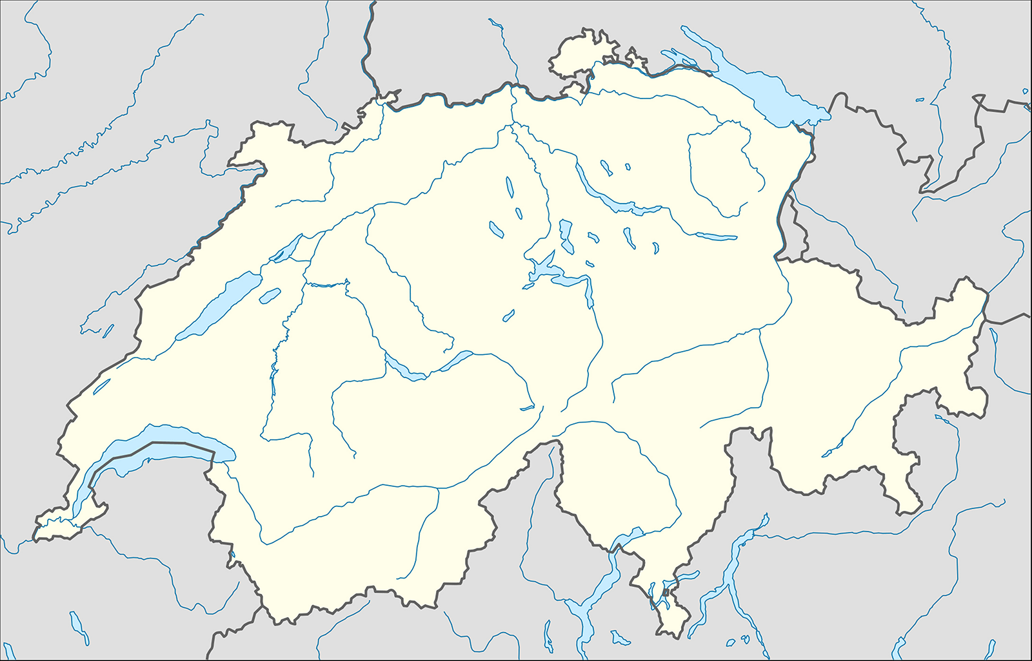
die Schweiz

