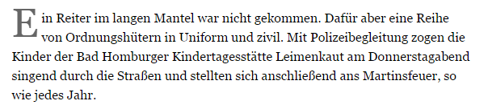Name: _________________________________ Datum: _______________________ Stunde: _____

