Name: __________________________________ Datum: _____________________Stunde: ______
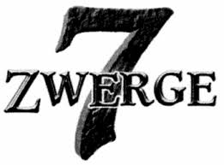

- Charakter Beschreibung. Write at least three (3) adjectives in the column below to describe the pictures of “7 Zwerge” characters. Use their character names to help infer a description.
Eigenschaften/ Personality :
barmherzig (compassionate)
depremiert (depressed)
dickköpfig (stubborn)
eitel (vain)
ernst (serious)
erregt (excited)
faul (lazy)
fleißig (hard-working)
freundlich (friendly)
geduldig (patient)
gemein (mean)

-

gerissen (sly)
gierig (greedy)
großzügig (generous)
jähzornig (violent-tempered)
klug (smart)
komish (funny, weird)
merkwürdig (strange)
nervös (nervous)
redselig (talkative)
religiös (religious)
sanft (gentle)

schlechtgelaunt (bad-tempered)
schüchtern (shy)
schlau (clever)
spaßig (amusing)
sportlich (athletic)
tapfer (courageous)
traurig (sad)
ein Träumer (a dreamer)
ungeduldig (impatient)
witzig (witty, funny)
zufrieden (happy; satisfied)

Schauspieler & Character | Bild | Adjektive
Otto Waalkes  (Bubi) | 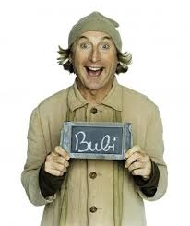
Boris Aljinovic (Cloudy)
Schauspieler & Character | Bild | Adjektive
Gustav Peter Wöhler
(Cookie)
Norbert Heisterkamp (Ralfie)
Martin Schneider (Speedy)
Ralf Schmitz (Sunny)
Mirco Nontschew (Tschakko)
Heinz Hoenig (Brummboss)
Schauspieler & Character | Bild | Adjektive
Cosma Shiva Hagen (Schneewittchen)
Nina Hagen
(Hexe)

- Wortschatz: Look up the following vocabulary words using either a dictionary or LEO app or website. Please write in the correct article for each noun listed in the left column below. The right column are composed of verbs and adjectives.
11. wagen
12. sägen
- zugeben
- verschwinden
- foltern
- erwarten
- gefährlich
- verdächtigt
- enttäuscht
- bescheurt

- _____ Versuchung
- _____ Zipfel
- _____ Duft
- _____ Unglück
- _____ Narr
- _____ Belohnung
- _____ Segen
- _____ Schicksal
- _____ Zufall
- _____ Wahrheit
die

